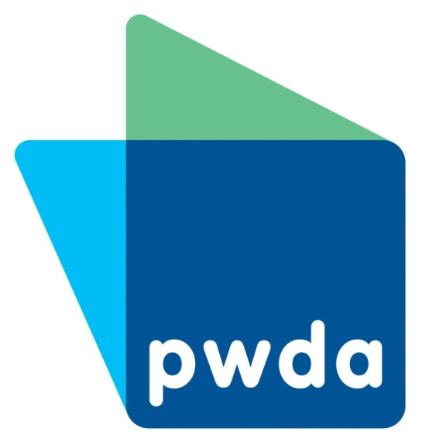

Join People with

Disability Australia



This means you become a member.



**Member form**

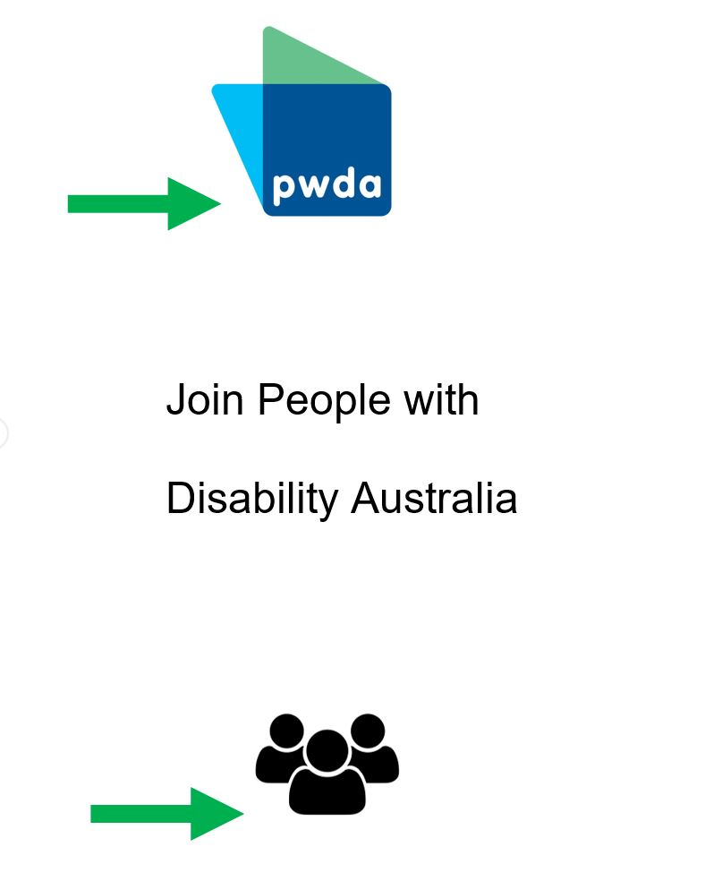

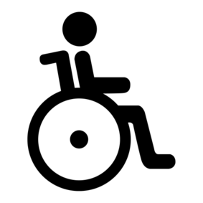

1. My name _________________________________



1. 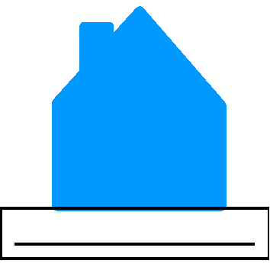Where I live _______________________________

___________________________________________

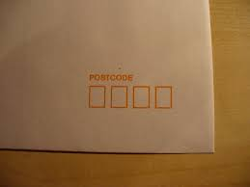

1. Post code
2. 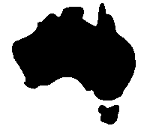I live in

**?**

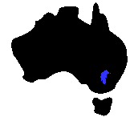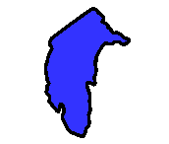

ACT

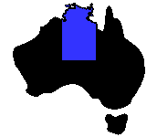

Northern Territory

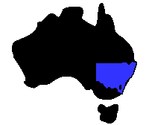

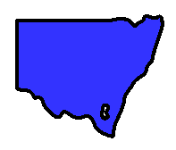

NSW

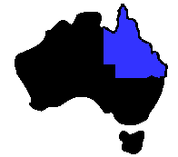

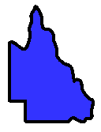

Queensland

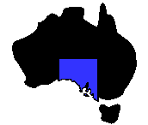

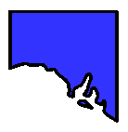

South Australia

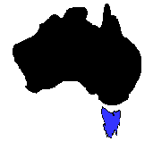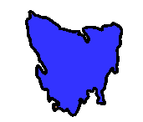 Tasmania

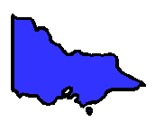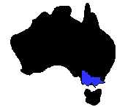

Victoria

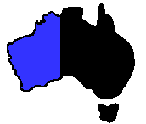

Western Australia

1. 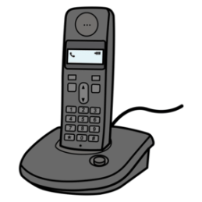Phone

Home _________________________________

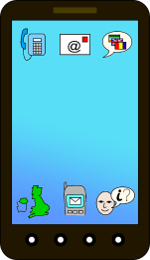

Mobile _________________________________

1. 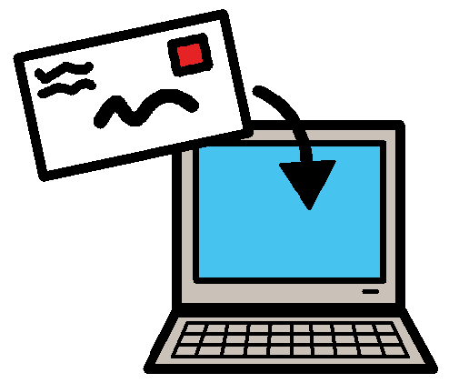Email ___________________________________



1. We send information to our members.

I want to get my information



by email

**or**

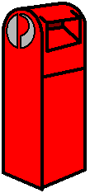

by post.

1. 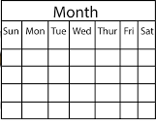I want to get the newsletter?

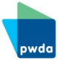It comes every 2 weeks.

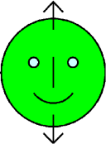.

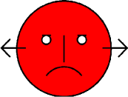

Yes No

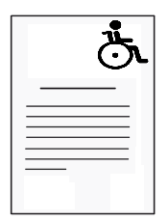

9. I want to get any stories in the news

about disability?

It comes every day. It only comes by email.

.



Yes No

10. I have an interest in



The NDIS

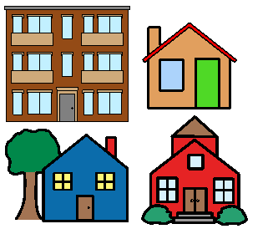

a place to live.

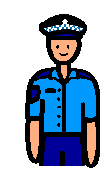

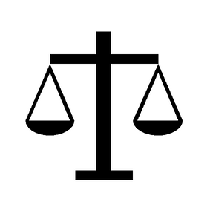 how we can work with the

* police
* courts.

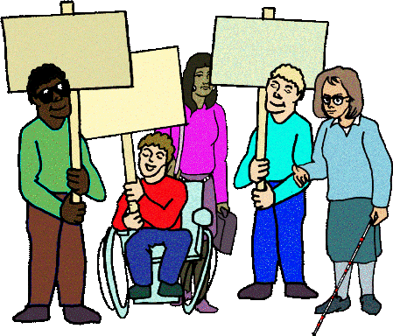 how we speak up about problems we have.



how to look for answers to our problems.



teach other people about us.

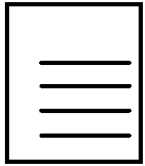11. Private Information

There are rules about private information.

Like where we keep your address.

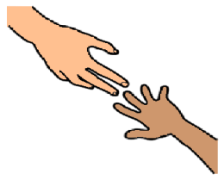

I need help to understand the rules.

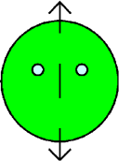

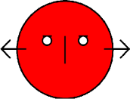

Yes No

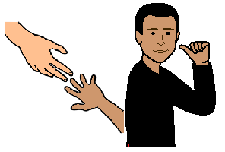

I need help to know what the rules mean for me.



Yes No



I have read these rules.





Yes No

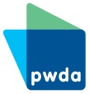

12. We have rules about being a member.



I need help to understand the rules.





Yes No



I need help to know what the rules mean for me.

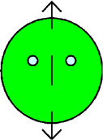

Yes No



I have read these rules.





Yes No



12. Send us this form by

Post

P.O. Box 666

Strawberry Hills NSW 2012

**or**

Email pwd@pwd.org.au

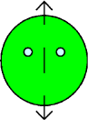**Images**

We have used images from

* COMPIC
* Inspired Services
* Mayer-Johnson
* Picto - Selector
* Pinterest.

This form is based on the PWDA membership form on our website**.**

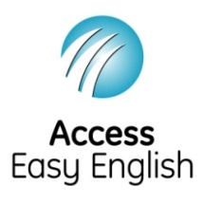Access Easy English wrote the Easy English.

October 2018.